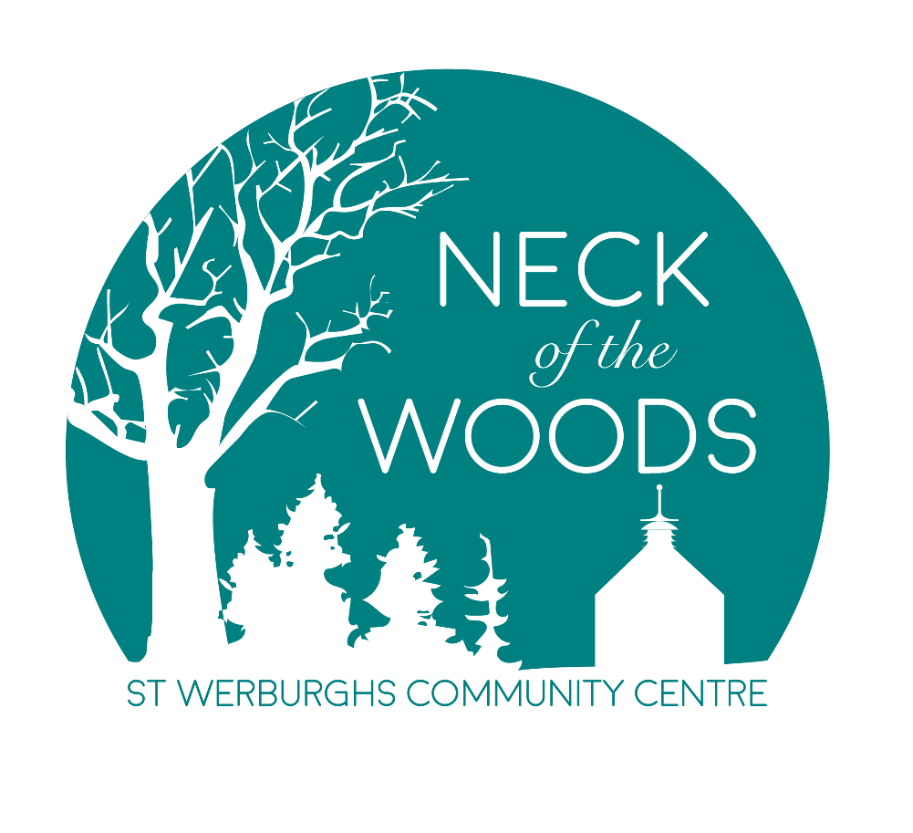
A Community Vision and Plan
NECK of the WOODS is a conscious café with permaculture and sustainability inspiring our core values. Situated at the heart of St Werburghs Community Centre in its bright and airy space serving fresh and local food for breakfast, lunch and events.

Come park your buggy, your laptop or your backpack in our friendly, cheerful environment. We believe that it is really important to give back and are always looking at new ways to invest into our community and with your support hope to make a lasting effect.
Friendly service, colourful salads, loaded sandwiches, speciality coffee and home baked goodies are prepared daily.

Come find us in your neck of the woods.

Vision
Our vision is for a Community Café in St Werburghs showcasing and utilising the best of local food to produce high quality dishes and beverages whilst bringing together all members of our community, providing a focus point for community events, and offering volunteering and work experience opportunities for all sections of the community.
We will do this through:
1. Producing high quality food using local produce
2. Running and encouraging a range of social activities to include and integrate all sections of our community
3. Providing volunteering and work experience
4. Running and supporting local events
5. Providing space for meetings and for people to sell arts and crafts and produce
6. Offering a pay it forward scheme
7. A commitment to reinvesting into the Centre and nominated community projects

We aim to deliver our vision through:

1. Producing high quality food using local produce
Our menus will be designed to appeal to the different sections of the community. We will source as much of our produce from local suppliers and other providers. Food will be freshly cooked and prepared on the premises with options on the menu for vegetarians, vegans, coeliac, and those with allergies/intolerances etc. We will develop the menu over time, some examples of the types of food we would like to do are below:
- Breakfast, lunch, cakes and snacks: A full range of breakfast items to cater to all wallets and bellies. A delicious range of sandwiches, salads, soups and seasonal items, some simpler meals for quick visits whilst providing slightly more indulgent lunches for those wanting to sit in and enjoy the atmosphere. Homemade cakes and pastries, changing daily, will be available throughout the day, you may even discover some Brazilian inspired treats on the counter.
- Drinks: we will provide a full range of beautifully crafted coffees and teas, soft drinks, juices and smoothies.
- Events: We aim to offer a range of evening and pop up events tailored to the needs and requests of our community.
- Catering: We will offer a full and flexible catering menu to local businesses and Centre users.
2. Running and encouraging a range of social activities to include and integrate all sections of our community
The environment that we create in the café is just as important as our food and drinks, we want to encourage community involvement, mindfulness, inclusion, creativity and a sense of ownership.
- Social and leisure groups: We are committed to consulting and encouraging individuals within our community to set up a range of groups, with an overall aim focused on integrating everyone around with common interests to improve community cohesion.
- Knowledge sharing: Learning and sharing knowledge is one of the keys to community success and bringing together isolated groups.
- Pay it forward: We will have a pay it forward scheme which enables a customer to buy an extra item and donate it to the next person coming in needing it, we know that poverty is one of the causes of social isolation and we hope this scheme will encourage people out who couldn’t otherwise afford it.
3. Providing volunteering and work experience for people
We would like to create a space for volunteering opportunities for different members of the community to gain skills, experience and confidence to move onto employment, education or training.
4. Running and supporting local events
We would like our community to nominate local projects and organisation for whom we will focus fundraising projects and profit share.
5. Providing space for meetings and for people to sell arts and crafts, produce
We want to create a buzz and harness the knowledge and creativity of our local community and inspire others to be part of our venture. In addition to this, St Werburghs Community Centre has a range of function rooms available to hire.

How we have got to this point
We have been overwhelmed by the generosity and support of local businesses and individuals that have donated their time, expertise and equipment.
- St Werburghs Community Centre
- Boston Tea Party
- Extract Coffee Roasters
- Earthborn Paint
- Hill Ash Designs

All of whom have made this possible with an incredibly tight budget – THANK YOU from the bottom of our hearts for helping us create something which we hope our community can really feel part of and make positive changes for generations to come.
Developing a community vision
We want Neck of the Woods to be a valuable, useful and inclusive resource for the community. We will consult with local residents, centre users and customer base to ensure we retain and develop what is valuable and needed. To promote the social outcomes that we are aiming for we will build partnerships with local groups and organisation and individuals.
Publicity and promotion
We aim to use a range of marketing methods
- Leaflets and posters – Using 100% recycled materials
- We will use local media to create an interest in our venture
- Social media, including Facebook, Twitter & Instagram using @NOTWCAFE
- Face to face contact, food stall at the Picnic in the Park and talking to people to raise awareness about the café (initially to seek opinions about what they would like to see)
- Promotion through St Werburghs Community Centre

Meet the team
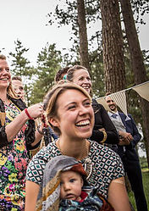

Jess: Born and raised here in Bristol, loves this incredible city and is passionate about bringing people together through delicious and sustainable food. Having just completed the SHIFT Bristol Permaculture course in St Werburghs. Jess is loaded with amazing insight on how to incorporate those principles into NECK of the WOODS. Previously a volunteer as Community Manager at Foodcycle and with heaps of experience with charity fundraising, pop-up food events and youth work.
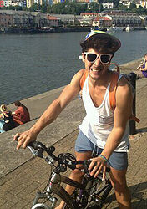
Murilo: Originally from Brazil (but having lived and worked in St Werburghs) where his family still live in the coffee growing mountains of Minas Gerais. With this coffee grounding (pun intended!) and nearly 10 years of experience working at Boston Tea Party ignited a passion for a well-crafted cup of the good stuff and of course prioritising great customer service and delicious produce. Community practice has always been a focus in Murilo's work, he trained as a dancer, runs two youth dance companies and has undertaken national tours.

Volunteers
We will create various volunteering roles, and develop policies and procedures in line with the Investing in Volunteers framework.
- Café volunteers
- Social group coordinators
- Publicity and promotion volunteers
- Fundraising volunteers
In the longer term we will look at how we can target some of these roles to people who want to gain skills and confidence for work and learn valuable skills the café can offer.

Grants and donations
St Werburghs Community Centre received £10k funding from Quartet Community Foundation’s Step Change Programme. This enabled us to redesign the space and buy equipment for the Café. St Werburghs Community Association which runs the Centre has also invested its own resources to make the project happen. The opportunity was advertised widely and the appointment of the Neck of the Woods was made via an open tender process.

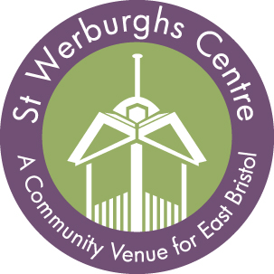

Contact us and follow us on social media
We would love to hear your views and suggestions
team@neckofthewoodcafe.co.uk
@notwcafe

